**Year 12 Examination, 2019**

**Question/Answer Booklet**

**MATHEMATICS SPECIALIST**

**Section Two: Calculator-assumed**

Student Name/Number: ______________________________________________

Teacher Name: ______________________________________________

**Time allowed for this section**

Reading time before commencing work: ten minutes

Working time for this section: one hundred minutes

**Materials required/recommended for this section**

**To be provided by the supervisor:** This Question/Answer Booklet

Formula Sheet (retained from Section One)

**To be provided by the candidate:**

Standard items: pens (blue/black preferred), pencils (including coloured), sharpener, correction fluid/tape, eraser, ruler, highlighters

Special items: drawing instruments, templates, notes on two unfolded sheets of A4 paper, and up to three calculators approved for use in the WACE examinations

**Important note to candidates**

No other items may be taken into the examination room. It is **your** responsibility to ensure that you do not have any unauthorised notes or other items of a non-personal nature in the examination room. If you have any unauthorised material with you, hand it to the supervisor **before** reading any further.

**Structure of this paper**

|  |  |  |  |  |  |
| --- | --- | --- | --- | --- | --- |
| Section | Number of questions available | Number of questions to be answered | Working time (minutes) | Marks available | Percentage of exam |
| Section One: Calculator-free | 8 | 8 | 50 | 50 | 35 |
| Section Two: Calculator-assumed | 10 | 10 | 100 | 100 | 65 |
|  | | | | | 100 |

**Instructions to candidates**

1. The rules for the conduct of School exams are detailed in the *_______________________________________School/College assessment policy*. Sitting this examination implies that you agree to abide by these rules.
2. Write your answers in this Question/Answer booklet preferably using a blue/black pen. Do not use erasable or gel pens.
3. You must be careful to confine your answer to the specific question asked and to follow any instructions that are specified to a particular question.
4. Show all your working clearly. Your working should be in sufficient detail to allow your answers to be checked readily and for marks to be awarded for reasoning. Incorrect answers given without supporting reasoning cannot be allocated any marks. For any question or part question worth more than two marks, valid working or justification is required to receive full marks. If you repeat any question, ensure that you cancel the answer you do not wish to have marked.
5. It is recommended that you do not use pencil, except in diagrams.
6. Supplementary pages for planning/continuing your answers to questions are provided at the end of this Question/Answer booklet. If you use these pages to continue an answer, indicate at the original answer where the answer is continued, i.e. give the page number.
7. The Formula sheet is not to be handed in with your Question/Answer booklet.

**Section Two: Calculator-assumed 65% (100 Marks)**

This section has **10** questions. Answer **all** questions. Write your answers in the spaces provided.

Supplementary pages for planning/continuing your answers to questions are provided at the end of this Question/Answer booklet. If you use these pages to continue an answer, indicate at the original answer where the answer is continued, i.e. give the page number.

Working time: 100 minutes.

**Question 9 (6 marks)**

(a) Solve the equation  giving answers in the form cis. (3 marks)

1. If the two solutions of the equation are denoted and  determine all the positive integers such that . (3 marks)

**Question 10 (10 marks)**

The path of a particle is defined by **rij** metres with  measured in seconds.

(a) Show that the equation of the path is (3 marks)

.

(b) Describe this trajectory geometrically. (1 mark)

(c) Derive an expression for the velocity **v**. (1 mark)

1. Obtain an expression for the speed of the particle in terms of . (3 marks)
2. Hence determine the maximum speed of the particle.

At what times is this speed attained? (2 marks)

**Question 11 (6 marks)**

The graph of $y=f(x)$ is shown below.

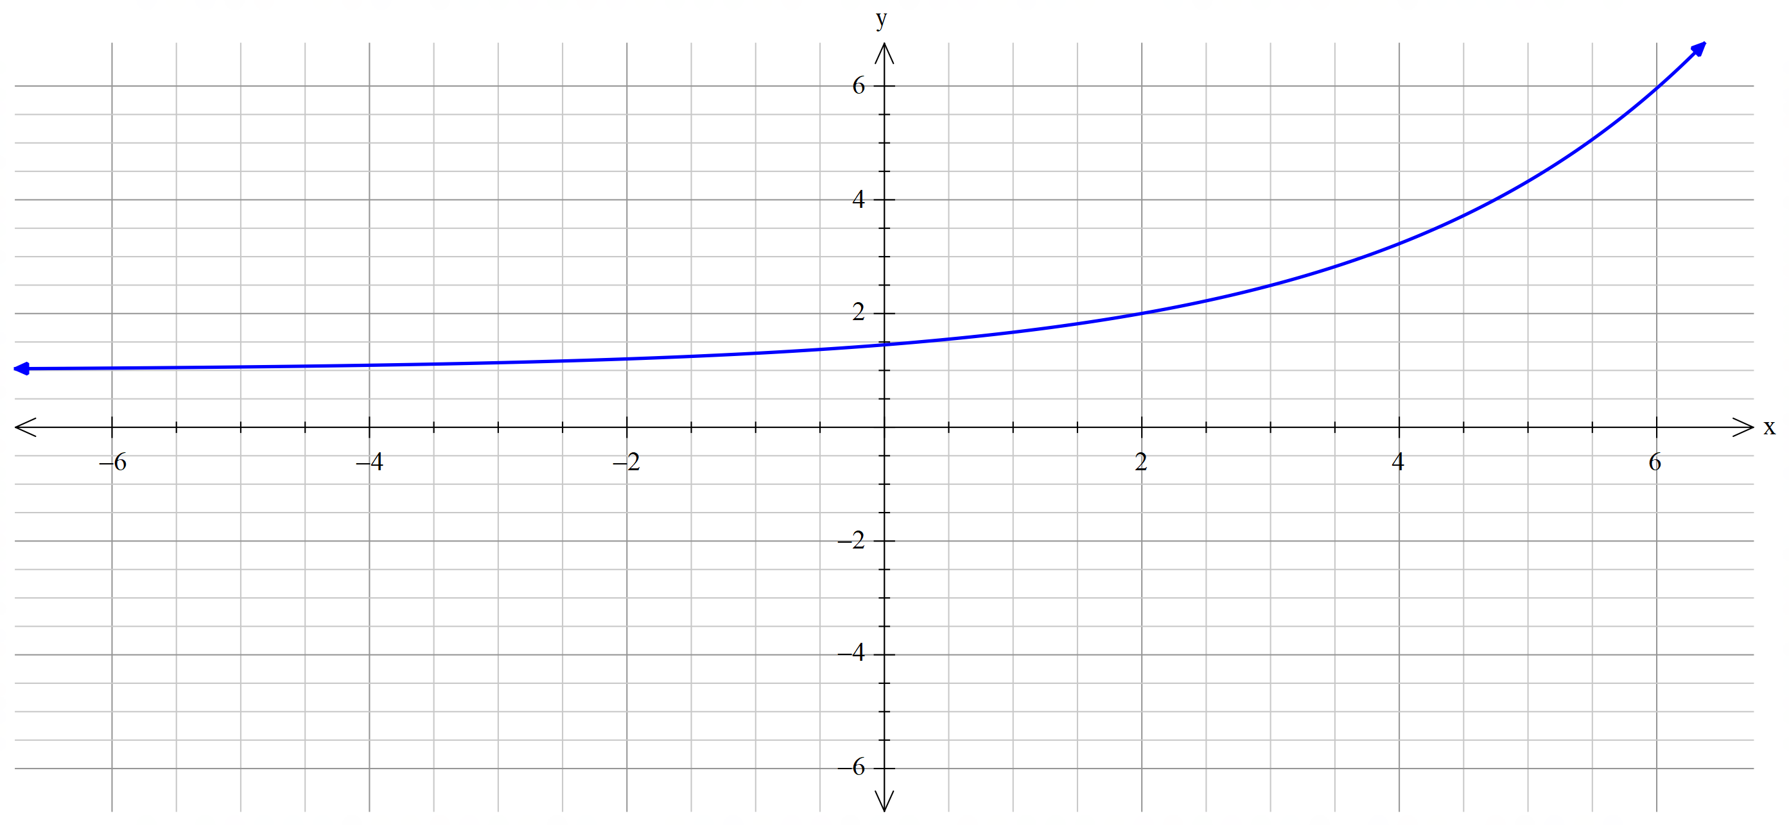

(a) Sketch on the same axes the graph of . (3 marks)

(b) Sketch on the same axes the graph of . (3 marks)

**Question 12 (8 marks)**

Sketch and clearly identify the region in the Argand diagram that represents the complex numbers that satisfy both  and .

Show clearly the co-ordinates of any key points.

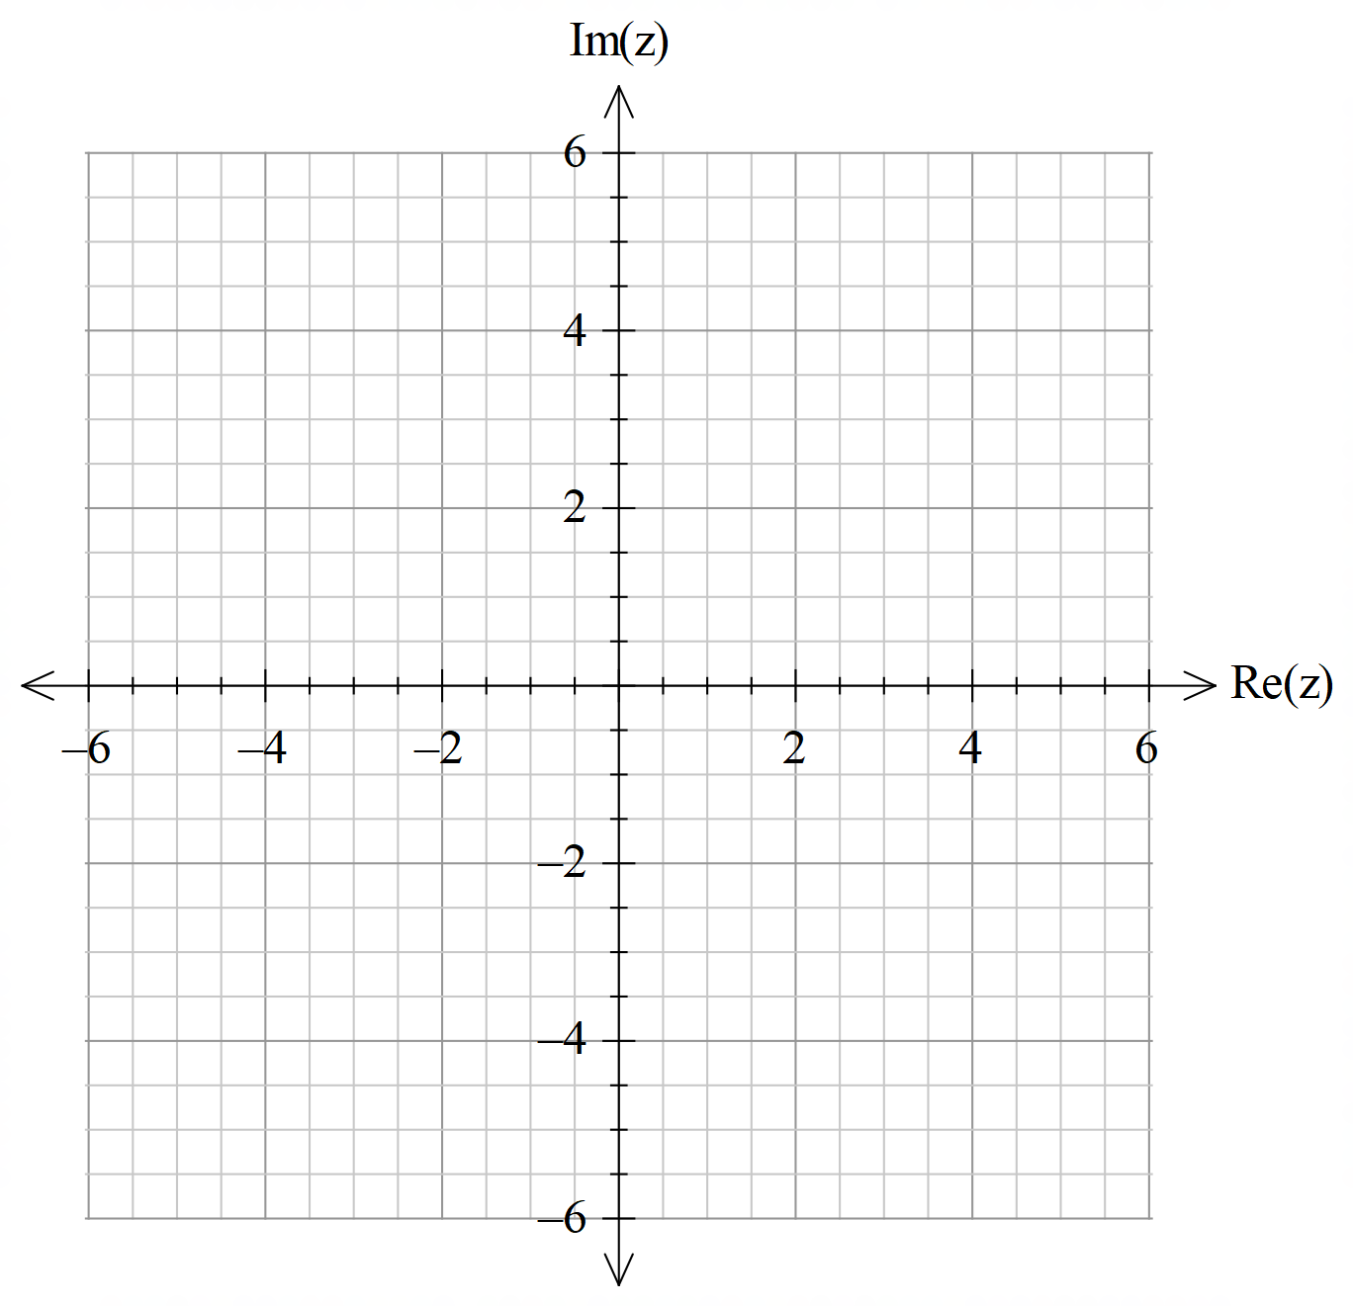

**Question 13 (13 marks)**

A projectile is shot from a gun G at an angle of elevation of 45° and with muzzle velocity 140 m/s. The acceleration due to gravity is $-9.8$**j** where the unit vectors **i** and **j** are horizontal and vertical vectors respectively.

Determine:

(a) the position vector (relative to G) of the projectile at any time *t* (7 marks)

(b) the maximum height attained by the projectile (2 marks)

(c) the total flight time of the projectile (2 marks)

(d) the speed of the projectile upon impact. (2 marks)

**Question 14 (13 marks)**

Consider the function

.

(a) Determine the location of all zeros and critical points of , the behaviours of as and the vertical asymptotes of the graph of. (8 marks)

(b) Sketch on the axes below the graph of . (5 marks)

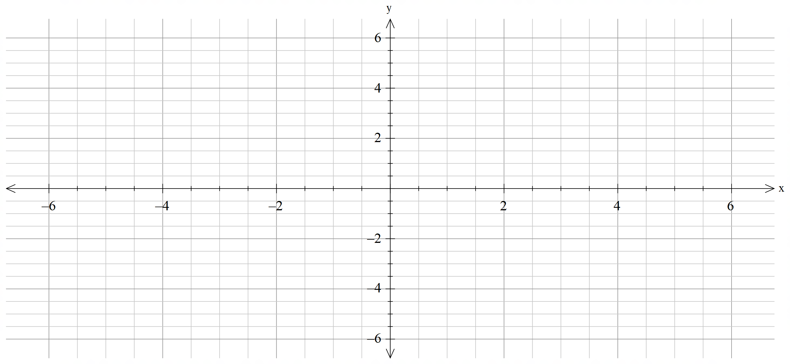

**Question 15 (9 marks)**

1. Show that for any angle , (3 marks)

.



1. Use this result to prove that (6 marks)

.

**Question 16 (10 marks)**

1. Use an algebraic method to determine the real values and such that is a factor of

. (6 marks)

1. Hence solve giving all the answers in Cartesian form. (4 marks)

**Question 17 (10 marks)**

Suppose that , where  is a constant.

(a) Use your calculator to obtain sketches of the graphs of  for the values and . Display these three graphs on these on the axes below. Indicate clearly which graph is which.

(3 marks)

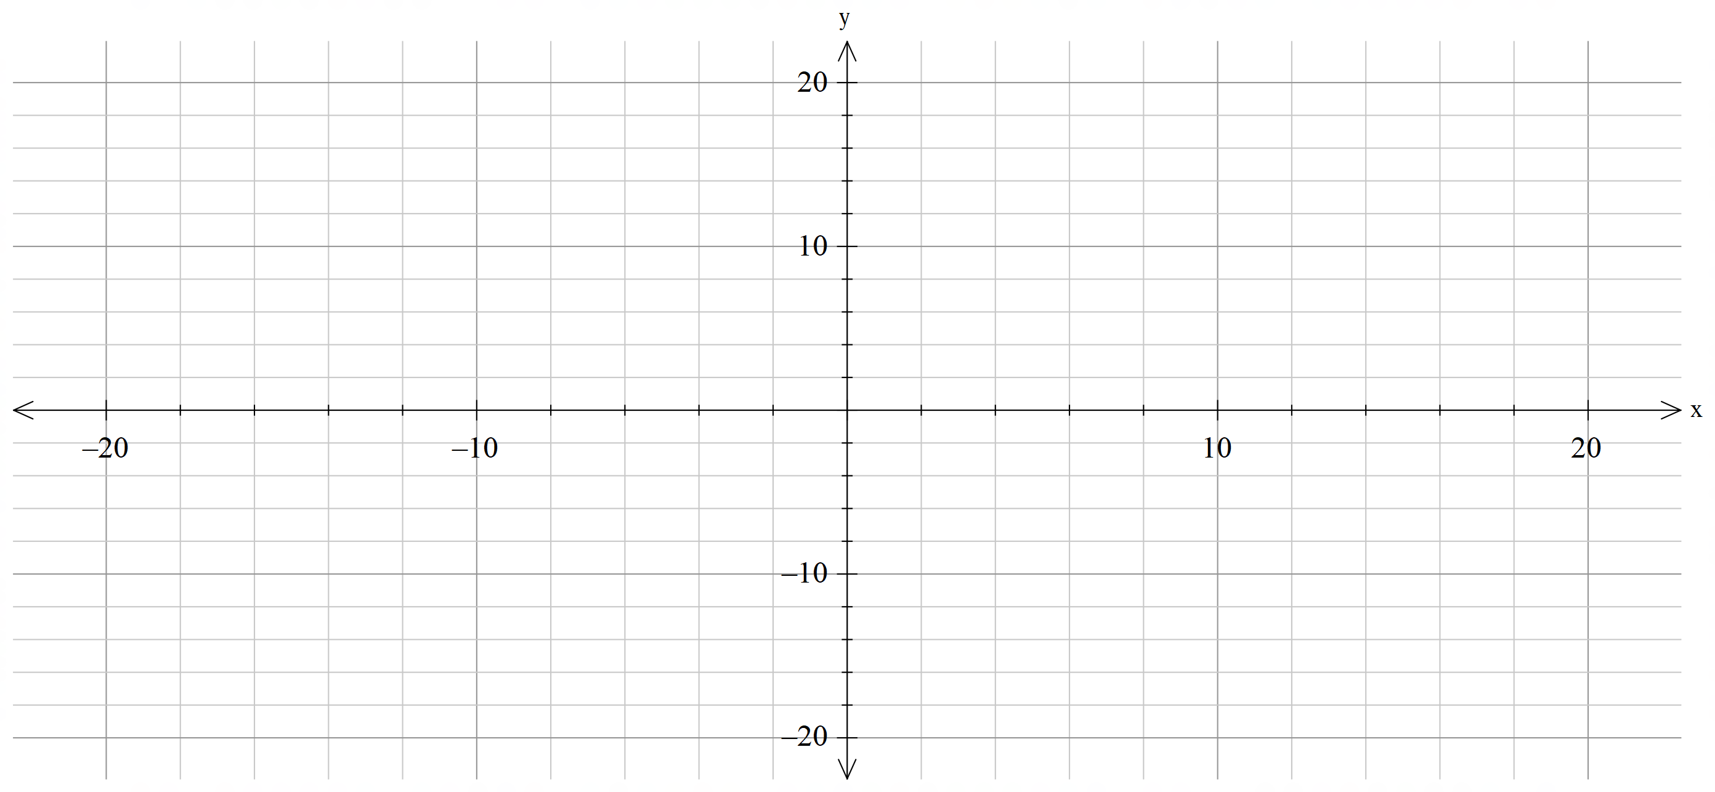

(b) For what values of  is the function $f$ one-to-one?

Justify your answer by considering the derivative . (4 marks)

(c) Use your calculator to estimate, correct to decimal places the value of when . (3 marks)

**Question 18 (15 marks)**

An airplane is flying with a constant velocity of **v****i****j****k** km/h and at 1 p.m. on a particular day it is at the location **r****i****j****k** km.

At the same time, a helicopter is located at **i****j****k** km and is moving at a velocity of **i****j****k** km/h.

1. If the aircraft continue in the manner described above, prove that they will collide.

(6 marks)

1. Determine the time and location of the collision. (2 marks)

1. At 2 pm. an air traffic controller realises that a collision will occur unless some avoidance action is taken.

The controller asks the airplane to change its velocity to **i****j****k** km/h.

Determine the closest distance the aircraft come to each other following this redirection. (7 marks)

**END OF QUESTIONS**

**Additional working space**

Question number: __________________

**Additional working space**

Question number: __________________

**Additional working space**

Question number: __________________

**Additional working space**

Question number: __________________

**Acknowledgements**

© MAWA, 2019

This examination is Copyright but may be freely used within the school that purchases this licence.

* The items that are contained in this examination are to be used solely in the school for which they are purchased.
* They are not to be shared in any manner with a school which has not purchased their own licence.
* The items and the solutions/marking keys are to be kept confidentially and not copied or made available to anyone who is not a teacher at the school. Teachers may give feedback to students in the form of showing them how the work is marked but students are not to retain a copy of the paper or the marking guide until the agreed release date stipulated in the purchasing agreement/licence.

*Published by The Mathematical Association of WA*

*12 Cobbler Place, MIRRABOOKA 6061*